Name of the event: All about Entrepreneurship and more.
Date: 18th August, 2018.
Start Time: 10:30 a.m.
End Time: 12:00 p.m.
Aim:
The sole aim of conducting this event was to bring a globally acknowledged speaker and encourage the students from various streams to gain more knowledge about the entrepreneurial world and how to become an entrepreneur.
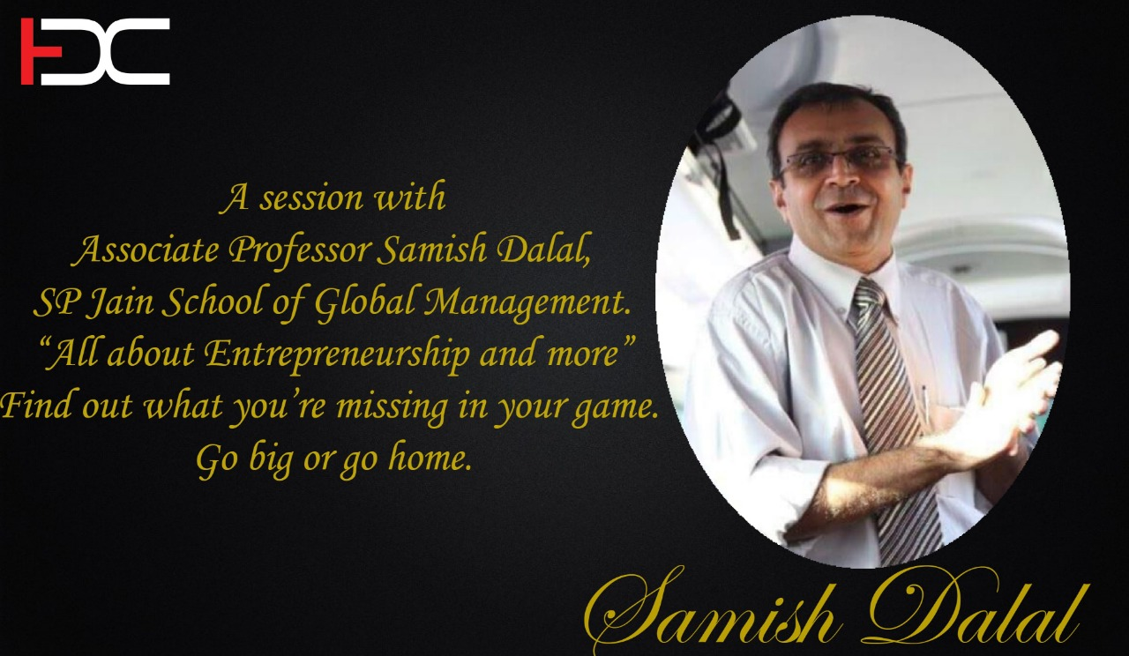
About the event:
The event was highly plausible and executed by the Board of Directors of the Entrepreneurship Development Cell. It was attended by more than 100 students from all the streams of the SIES College of Arts, Science and Commerce. Our Guest and a Brilliant Speaker, Prof. Samish Dalal, from S.P. Jain School of Global Management had graced the event with his presence. He conveyed to the students of how the 3 important aspects of an existing market can make a person to start his own venture and become an entrepreneur. The aspects were Identification of Gaps in existing market, the Emotional Attachment which the consumer has with a product and To Be an Entrepreneur who takes Risk and deals with it confidently. He shared his own experiences with these aspects and how he achieved immense growth in his life. Towards the end of his lecture; the Convener for EDC, Professor Uma Kokku felicitated Prof. Samish Dalal who motivated the students to create jobs rather than seeking one. The audiences’ feedback after the event included immense love and support towards the upcoming year.
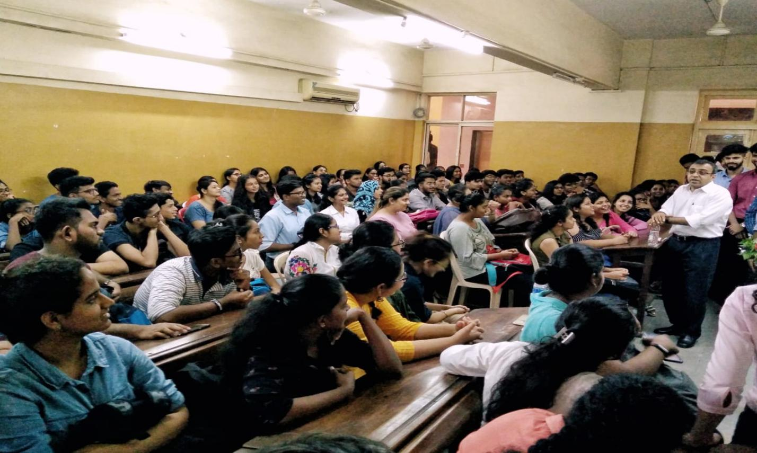
Summary:
Prof. Samish Dalal had grabbed everyone’s attention the minute he started talking. With his admirable knowledge about entrepreneurship and student-friendly humour, he gave an accountable insight to the students about entrepreneurial world, by which the students are looking forward for more such enthusiastic events by the EDC.

